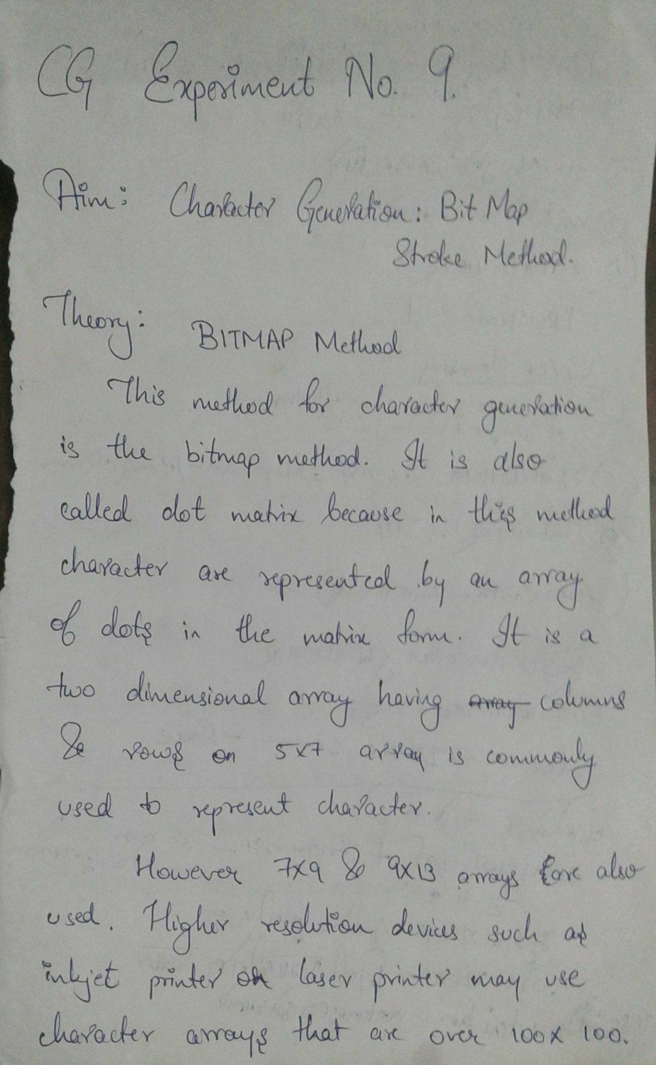

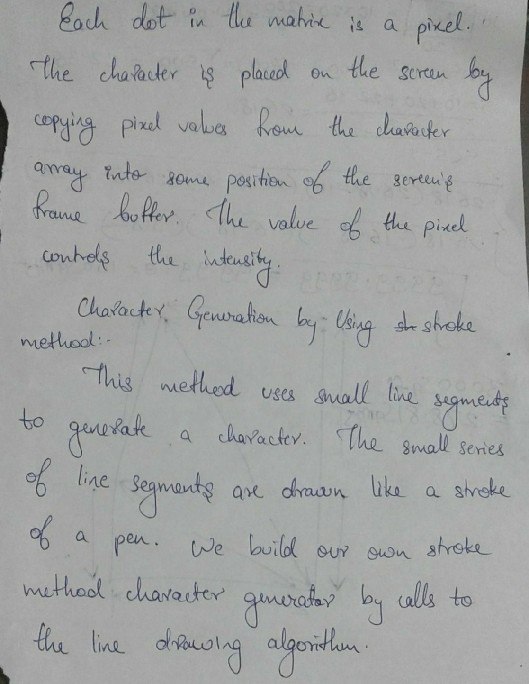

**-----------------------------------------------------------------**

**Program:**

1. **Bitmap Method:**

*#include <stdio.h>*

*#include <conio.h>*

*#include <graphics.h>*

*void main()*

*{*

*int i,j,k,x,y;*

*int gd=DETECT,gm;//DETECT is macro defined in graphics.h*

*/* ch1 ch2 ch3 ch4 are character arrays that display alphabets */*

*int ch1[][10]={ {1,1,1,1,1,1,1,1,1,1},*

*{1,1,1,1,1,1,1,1,1,1},*

*{0,0,0,0,1,1,0,0,0,0},*

*{0,0,0,0,1,1,0,0,0,0},*

*{0,0,0,0,1,1,0,0,0,0},*

*{0,0,0,0,1,1,0,0,0,0},*

*{0,0,0,0,1,1,0,0,0,0},*

*{0,1,1,0,1,1,0,0,0,0},*

*{0,1,1,0,1,1,0,0,0,0},*

*{0,0,1,1,1,0,0,0,0,0}};*

*int ch2[][10]={ {0,0,0,1,1,1,1,0,0,0},*

*{0,0,1,1,1,1,1,1,0,0},*

*{1,1,0,0,0,0,0,0,1,1},*

*{1,1,0,0,0,0,0,0,1,1},*

*{1,1,0,0,0,0,0,0,1,1},*

*{1,1,0,0,0,0,0,0,1,1},*

*{1,1,0,0,0,0,0,0,1,1},*

*{1,1,0,0,0,0,0,0,1,1},*

*{0,0,1,1,1,1,1,1,0,0},*

*{0,0,0,1,1,1,1,0,0,0}};*

*int ch3[][10]={ {1,1,0,0,0,0,0,0,1,1},*

*{1,1,0,0,0,0,0,0,1,1},*

*{1,1,0,0,0,0,0,0,1,1},*

*{1,1,0,0,0,0,0,0,1,1},*

*{1,1,1,1,1,1,1,1,1,1},*

*{1,1,1,1,1,1,1,1,1,1},*

*{1,1,0,0,0,0,0,0,1,1},*

*{1,1,0,0,0,0,0,0,1,1},*

*{1,1,0,0,0,0,0,0,1,1},*

*{1,1,0,0,0,0,0,0,1,1}};*

*int ch4[][10]={ {1,1,0,0,0,0,0,0,1,1},*

*{1,1,1,1,0,0,0,0,1,1},*

*{1,1,0,1,1,0,0,0,1,1},*

*{1,1,0,1,1,0,0,0,1,1},*

*{1,1,0,0,1,1,0,0,1,1},*

*{1,1,0,0,1,1,0,0,1,1},*

*{1,1,0,0,0,1,1,0,1,1},*

*{1,1,0,0,0,1,1,0,1,1},*

*{1,1,0,0,0,0,1,1,1,1},*

*{1,1,0,0,0,0,0,0,1,1}};*

*initgraph(&gd,&gm,"D:\\TC\\BGI");//initialize graphic mode*

*setbkcolor(LIGHTGRAY);//set color of background to darkgray*

*for(k=0;k<4;k++)*

*{*

*for(i=0;i<10;i++)*

*{*

*for(j=0;j<10;j++)*

*{*

*if(k==0)*

*{*

*if(ch1[i][j]==1)*

*putpixel(j+250,i+230,RED);*

*}*

*if(k==1)*

*{*

*if(ch2[i][j]==1)*

*putpixel(j+300,i+230,RED);*

*}*

*if(k==2)*

*{*

*if(ch3[i][j]==1)*

*putpixel(j+350,i+230,RED);*

*}*

*if(k==3)*

*{*

*if(ch4[i][j]==1)*

*putpixel(j+400,i+230,RED);*

*}*

*}*

*delay(200);*

*}*

*}*

*getch();*

*closegraph();*

*}*

1. **Stroke method:**

*#include <graphics.h>*

*#include <stdio.h>*

*#include <math.h>*

*#include <dos.h>*

*void main() {*

*float dx, dy, step;*

*int j, i, x[3], y[3], gd = DETECT, gm;*

*int p, q;*

*initgraph( & gd, & gm, "c:\\turboc3\\bgi");*

*for (j = 0; j < 3; j++) {*

*printf("Enter the value of x(j) and y(j) : ");*

*scanf("%d%d", & x[j], & y[j]);*

*printf("Enter the value of x(j+1) and y(j+1) : ");*

*scanf("%d%d", & x[j + 1], & y[j + 1]);*

*dx = abs(x[j + 1] - x[j]);*

*dy = abs(y[j + 1] - y[j]);*

*if (dx >= dy)*

*step = dx;*

*else*

*step = dy;*

*dx = dx / step;*

*dy = dy / step;*

*p = x[j];*

*q = y[j];*

*i = 1;*

*while (i <= step) {*

*putpixel(p, q, 15);*

*p = p + dx;*

*q = q + dy;*

*i = i + 1;*

*delay(100);*

*}*

*getch();*

*}*

*closegraph();*

*}*

**-----------------------------------------------------------------**

**Output:-**





